**IdGoBack Android Application**

by

Son Thai

Kane Carroll

Computer Science Department

College of Engineering

California Polytechnic State University

2013

Project Advisor: Dr. Franz Kurfess

Table of Contents

Page

Project Overview 3

Topic 3

Domain 3

Goal and Objectives 3

Intended Users 3

Relevance 3

System Personnel 3

Background 5

Existing Systems 5

Identification of technologies and Tools 8

System and User Requirements 8

Functional Requirements 8

Non-Functional Requirements 17

Evaluation Criteria 17

Experiments 18

User Tests 18

Expected Outcomes 18

Conclusions 18

# Project Overview

## Topic

The general problems to be addressed by the [IdGoBack](https://wiki.csc.calpoly.edu/IdGoBack/wiki/IdGoBack) Mobile Application are the following:

* Provide a reliable and easy to use mobile application
* Connect users to allow for easy photo and review sharing of the places they would "Go Back" to.

Although existing commercially available products have solved some of the problems mentioned, none satisfied all such problems. The [IdGoBack](https://wiki.csc.calpoly.edu/IdGoBack/wiki/IdGoBack) Mobile Application combines a set of features in a way that satisfies all problems addressed.

## Domain

We will develop and implement a mobile application for Android Platform.

## Goal and Objectives

To develop a fully functional android application that will be released onto the Google market for consumer use.

## Intended Users

Everyday users, common people who are looking for business/restaurant reviews via their mobile device.

## Relevance

Everyday people find themselves looking for new businesses to test out, or new restaurants to eat at. The [IdGoBack](https://wiki.csc.calpoly.edu/IdGoBack/wiki/IdGoBack) application makes it easy for consumers to look up local businesses or restaurants and review previous customers comments and opinions about a specific location.

## System Personnel

The personnel involved in the [IdGoBack](https://wiki.csc.calpoly.edu/IdGoBack/wiki/IdGoBack) Mobile Application project are organized into the following groups and subgroups:

1. End Users: those who use the [IdGoBack](https://wiki.csc.calpoly.edu/IdGoBack/wiki/IdGoBack) Mobile Application for its intended purpose.

* Facebook registered users
* End users who have registered and linked their [IdGoBack](https://wiki.csc.calpoly.edu/IdGoBack/wiki/IdGoBack) accounts with their Facebook accounts
* Stores photos and reviews in an [IdGoBack](https://wiki.csc.calpoly.edu/IdGoBack/wiki/IdGoBack) multi-user database
* [IdGoBack](https://wiki.csc.calpoly.edu/IdGoBack/wiki/IdGoBack) registered users
* End users who have registered and created accounts strictly through the [IdGoBack](https://wiki.csc.calpoly.edu/IdGoBack/wiki/IdGoBack) Mobile Application
* Stores photos and reviews in an [IdGoBack](https://wiki.csc.calpoly.edu/IdGoBack/wiki/IdGoBack) multi-user database
* Unregistered individual users
  + End users who have not created an account with [IdGoBack](https://wiki.csc.calpoly.edu/IdGoBack/wiki/IdGoBack).
  + No photo or review storage.
  + This type of user may only view existing photos and reviews
* System Administrators
  + - Perform overall system administration functions, including registration and account maintenance.

1. Customers

* The primary customer is Kevin Martin. Kevin Martin is the owner of [IdGoBack](https://wiki.csc.calpoly.edu/IdGoBack/wiki/IdGoBack).

1. System Developers

* Kane Carroll (kccarrol@calpoly.edu)
* Development activities include those of the software development process, from requirements analysis through product implementation, testing and deployment.
* Son Thai (sdthai@calpoly.edu)
  + Development activities include those of the software development process, from requirements analysis through product implementation, testing and deployment.

1. Project Adviser

* Dr. Franz Kurfess
  + - Provide feedback
    - Assess project progress

# Background

## 1. Existing Systems

1. Yelp: An application helps users to find the business in their area. Also, It provides users with deal and offers by these businesses. With Yelp application, users can choose the best business based on ratings and reviews by the past customers.

* Good features:
* The app can detect current location automatically.
* Users can have many options of business that they can choose.
* Users can use search option to search other businesses that are not listed in the nearby option.
* Users can bookmark their favorite business.
* User interface is friendly.
* Missing features:
* Users cannot link their Facebook or Twitter accounts to share with their friends on Facebook and Twitter.
* Users cannot sort all the search based on the ratings.

1. Urbanspoon: An application allows users to discover great restaurant in their neighborhood, or browser a comprehensive list of restaurants. Also, Urbanspoon allows users to make a reservation, expand their dine line by checking in, and share their favorite restaurants with their friends.

* Good features:
* Use GPS to find a restaurant near users.
* Filter by neighborhood, cuisine, or price.
* Search and browser local restaurants.
* See a list of all nearby eateries.
* Make reservations.
* Users can build and review their dining history.
* Compare restaurants picks with users' friends.
* Ratings and reviews from newspapers, bloggers, and fellow eaters.
* Nice and friendly user interface.
* Missing Features:
  + - The app does not allow users to sort the ratings so that users can just look at the best restaurants.
    - The app just allows user to search for restaurant only, not for all other business.

1. Foodspotting: An application allows users to spot all the best food in the area. The application also can detect current location automatically

* Good features:
* User friendly and good design.
* Pictures are taken with high resolution.
* Users can easily search for the best food and special food in local area.
* Users have options to log in the app by either signing in with email or linking with their Facebook account.
* Users can use camera to take the picture.
* The app allows user to see other users' activities, and how they rate the food.
* The app can detect location of the restaurant where food is sold and shows the distance from users' current location to the restaurant.
* Missing features:
* The app just allows users to found the best restaurants only. Users cannot search other business.

1. Alfred: An application helps users to pick best restaurant in the local based on the answers provided by users.

* Good features:
* Nice and friendly user interface.
* Users can synchronize the app using their Google or skip it but with some limits.
* The app detects user's current location by GPS.
* Users can filter all the restaurants based on the distance, the price, the cuisine, and the services.
* Bad features:
* Users can only log in their account only if they have Google account.
* Missing feature
* Users cannot link their Facebook to the app so they can share their favorite restaurants with their friends.
* The app just recommends the best restaurants to the users only. It does not help users find other best business.
* Users cannot sort recommendations based on ratings so that users can save their time searching.
* Users cannot take the pictures with this app.

1. Qype: An application helps users to find the right places such as restaurants, bars, shops, doctors, and hotels.

* Good Features:
* Users can users personalized recommendations to find the best place in their local.
* The app allows users to search many different businesses such as restaurants, hotel, bars, shops, and nightlife.
* The app provides users with detailed information that they are searching.
* Users can use check-in features to share their locations with their friends on both Qype and Facebook.
* Users can read reviews in eight languages.
* Users can search for the best places in very specific areas by the Map Explore Tool.
* Users can take pictures with their camera and write a review easily.
* Users have options to log in their account: Facebook, Gmail, Twitter, or Qype account
* Bad Features:
* The app does not predict accurately where users are.
* The app does not synchronize well with the website. Users sometimes cannot find the reviews that exists on the Qype website.
* The app does not provide a full list of all the local business.
* The app is confusing to use.
* Missing Features: ¶
* The app does not automatically detect users' current location when users use search option.

1. Instagram: An application allows users to share their photos in a simple photo stream with friends to see - and follow their friends' photo with the click of a single button. Also, users can find the best business in their local based on reviews and likes from their friends and others.

* Good Features:
* Users have options to log in account by either linking to their Facebook or signing in with their email or Instagram account.
* Nice and friendly interface.
* Good quality of pictures taken.
* Users can take and share their pictures to Facebook, twitter, Flickr, Tumblr, Foursquare, and Posterous.
* Users can interact with their friends through giving and receiving likes and comments.
* GPS can help users to detect their current location.
* Bad Features:
* Users have to log in their account to be able to access to Instagram app.
* Missing Features:
* Users to sort their followers/following list.
* Users cannot delete more than one picture at once.

## 2. Identification of technologies and Tools

1. Tools:

* Java with Eclipse Platform

1. Technologies

* Camera
* Facebook API
* City Grid API
* Parse Hosting

# System and User Requirements

## Functional Requirements

1. User Interface Review
2. Creating an Account
3. Log In
4. Explore

The Explore tab allows users to search for restaurants, places, business Also, the Explore tab allows user to search by either their current location automatically detected by GPS or specific locations provided by the user. In this scenario, the user is assumed to have just logged in the application. Therefore, the user is led to the 'Explore' tab by default.

User sees the screen displayed as in the Figure 1

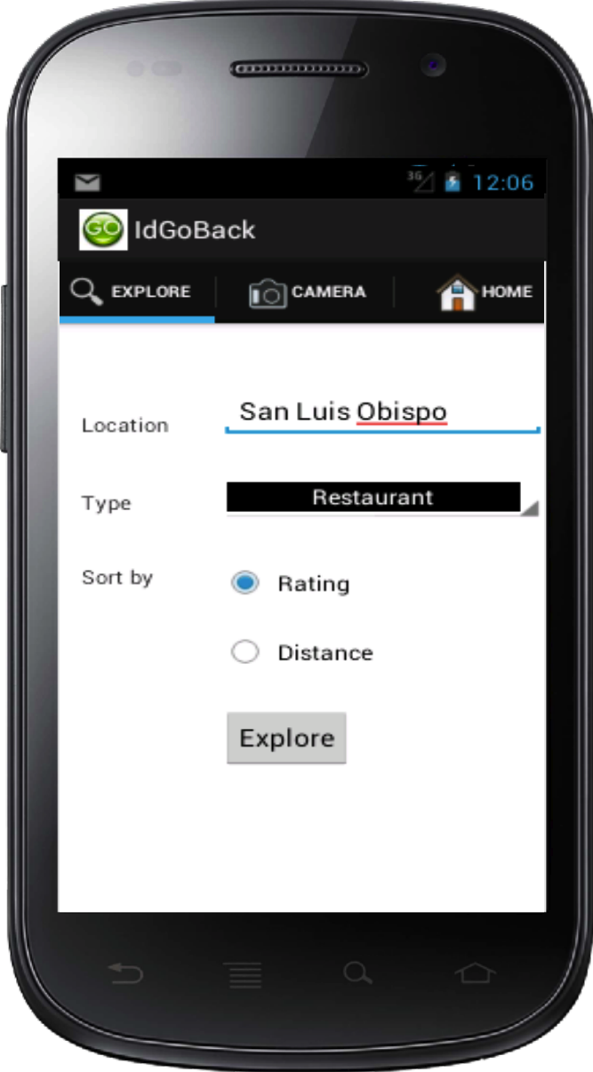

Figure 1: Initial screen after user logs in the application

The location text field displays the location that user want to search for. The type spinner contains different keywords such as restaurant, movie theater, hotel, shopping, bar club, spa beauty, and business allowing user to search easily. Also, user can filter the search by rating or distance of places in the area.

When user clicks on the explore button, user see screen displayed as in Figure 2. Each item listed in the list view includes the name of the place, the distance from user’s current location, and the rating of that place.

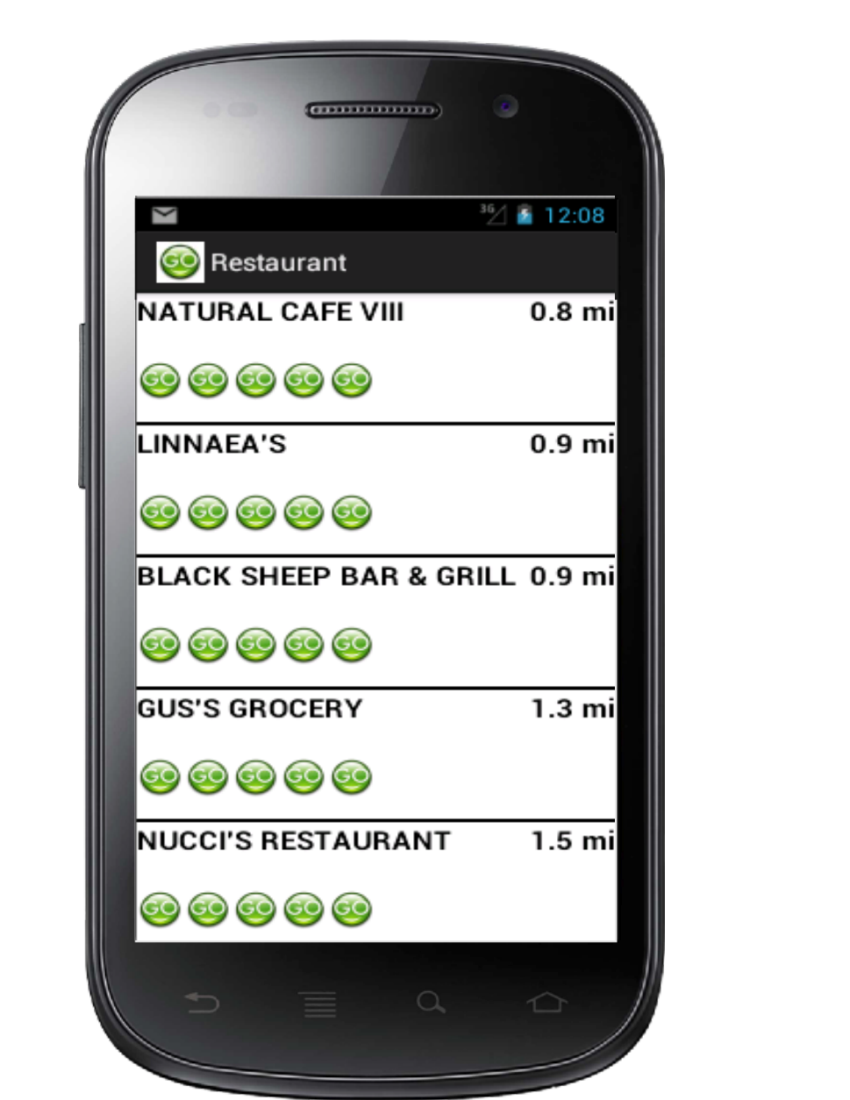

Figure 2: List of places in the area searched by the keyword.

1. Information Detail

When the user clicks on the item on the list, user is led to the view that shows the information details about that place as displayed in Figure 3.

There are 4 different tabs: Info, Review, Photo, and Upload Photo tabs. By default, the user is directed to Info.

The Info tab provides user details of chosen place such as name of place, overall rating of the place, operation hours (if available), the address, the phone number, and the website (if available). When user clicks on the website link, user is directed to the place’s website. Also, there is a static Google map showing location of the place on the map. At the end of the screen, there is a direction button. When user clicks on the button, the built-in Google map is popped out showing the direction from user’s current location to the chosen place in the driving mode.

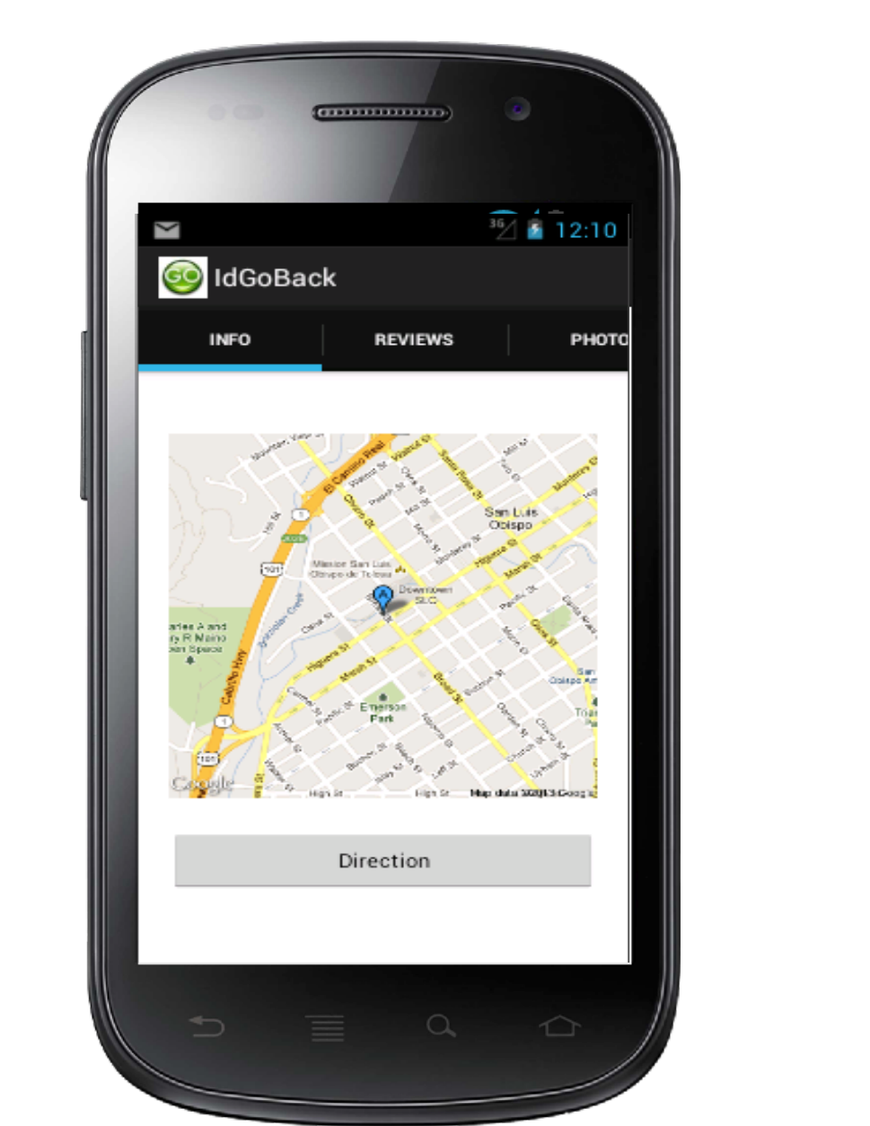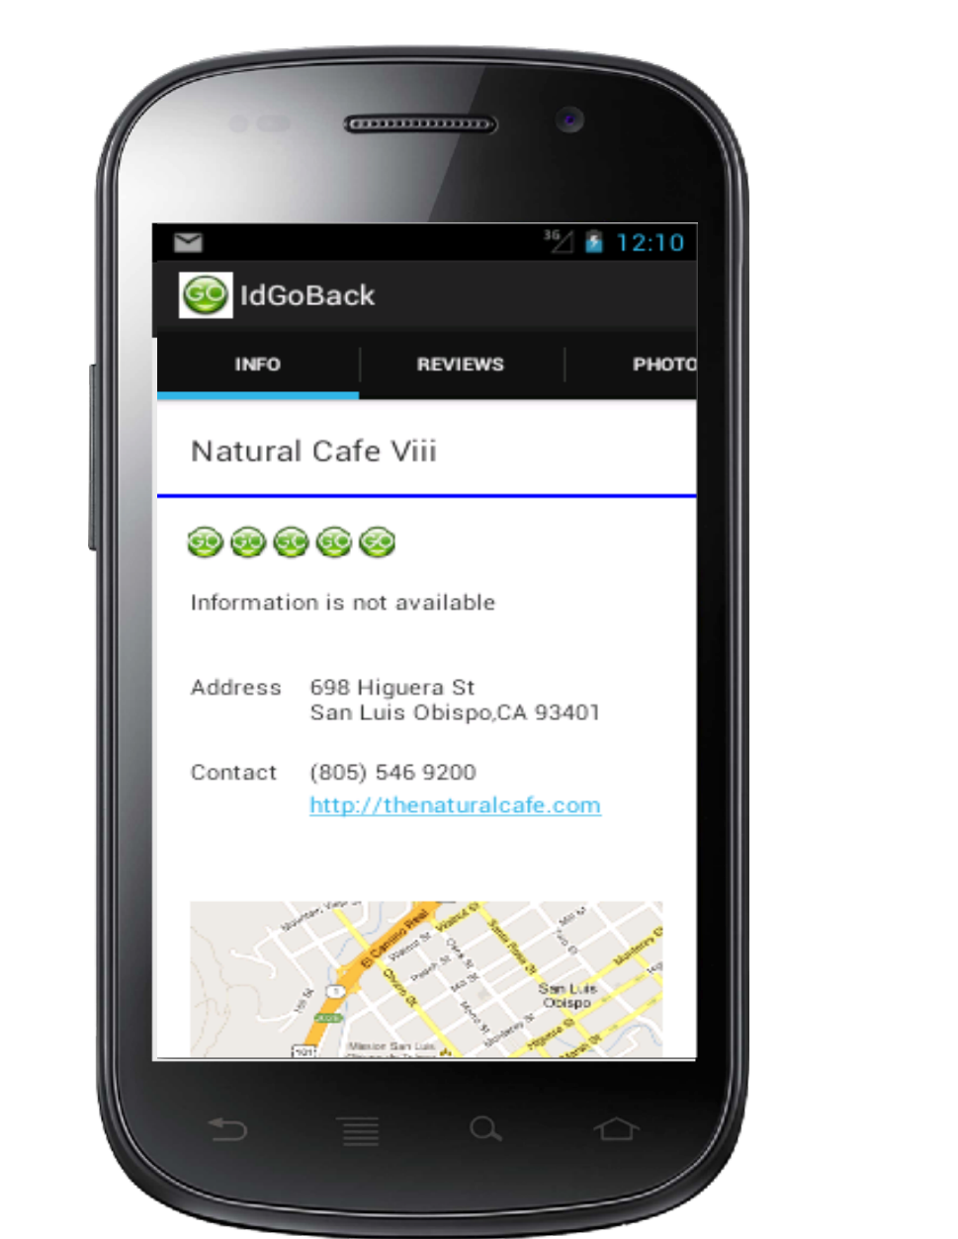

Figure 3: Information detail of chosen place.

1. Review

When user clicks on Review tab, user sees overall rating of the place, the total number of reviews, and all the reviews, date, and rating from previous customers about the chosen place as displayed in Figure 4.

Also, user is able to add a new review for the chosen place by clicking on the add review button on the top right corner. When user clicks on the button, there is a pop-up dialog that allows user rating and giving that place. The review date is automatically filled with current date. When user click on the submit button, the review is immediately shown in the review list view, and stored in the database.

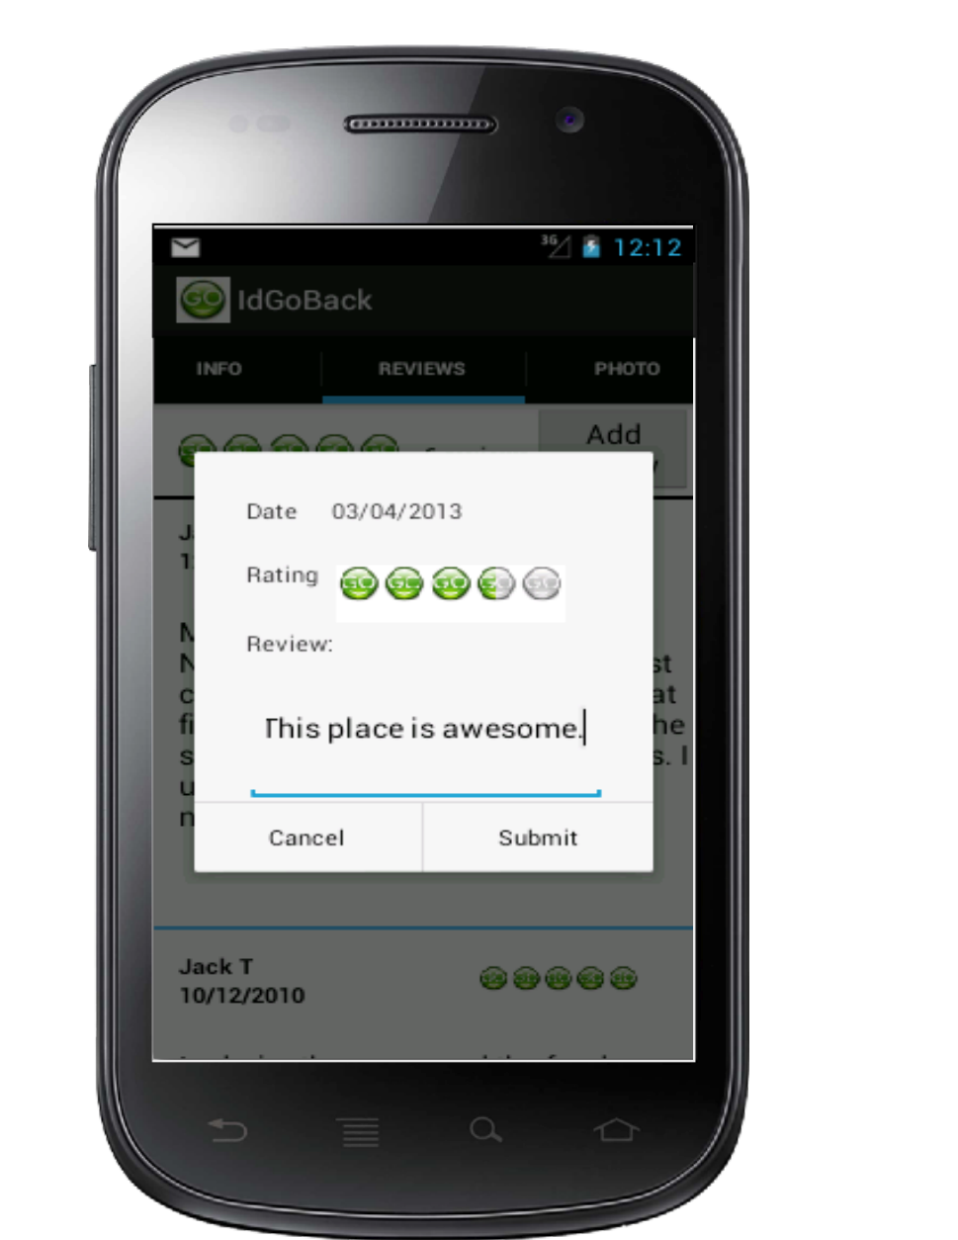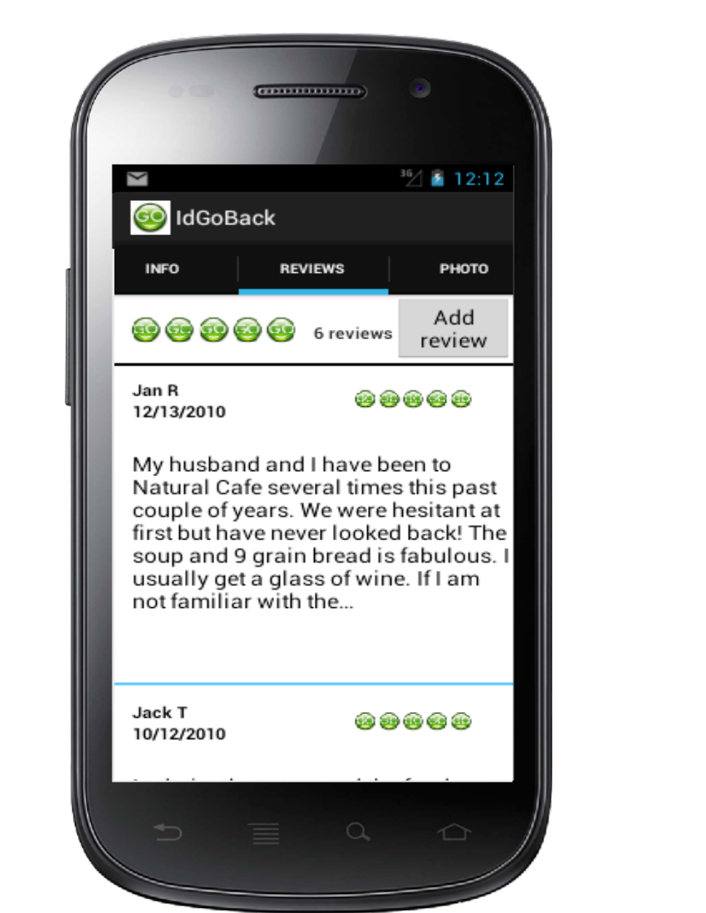

Figure 4: Reviews about the chosen place and adding a new review

1. Photo

When user clicks on Photo tab, all the photos of the chosen place shared by IdGoBack user are loaded on the screen as displayed in Figure 5. User is able to click on the photo to see its larger size with the review for that photo.

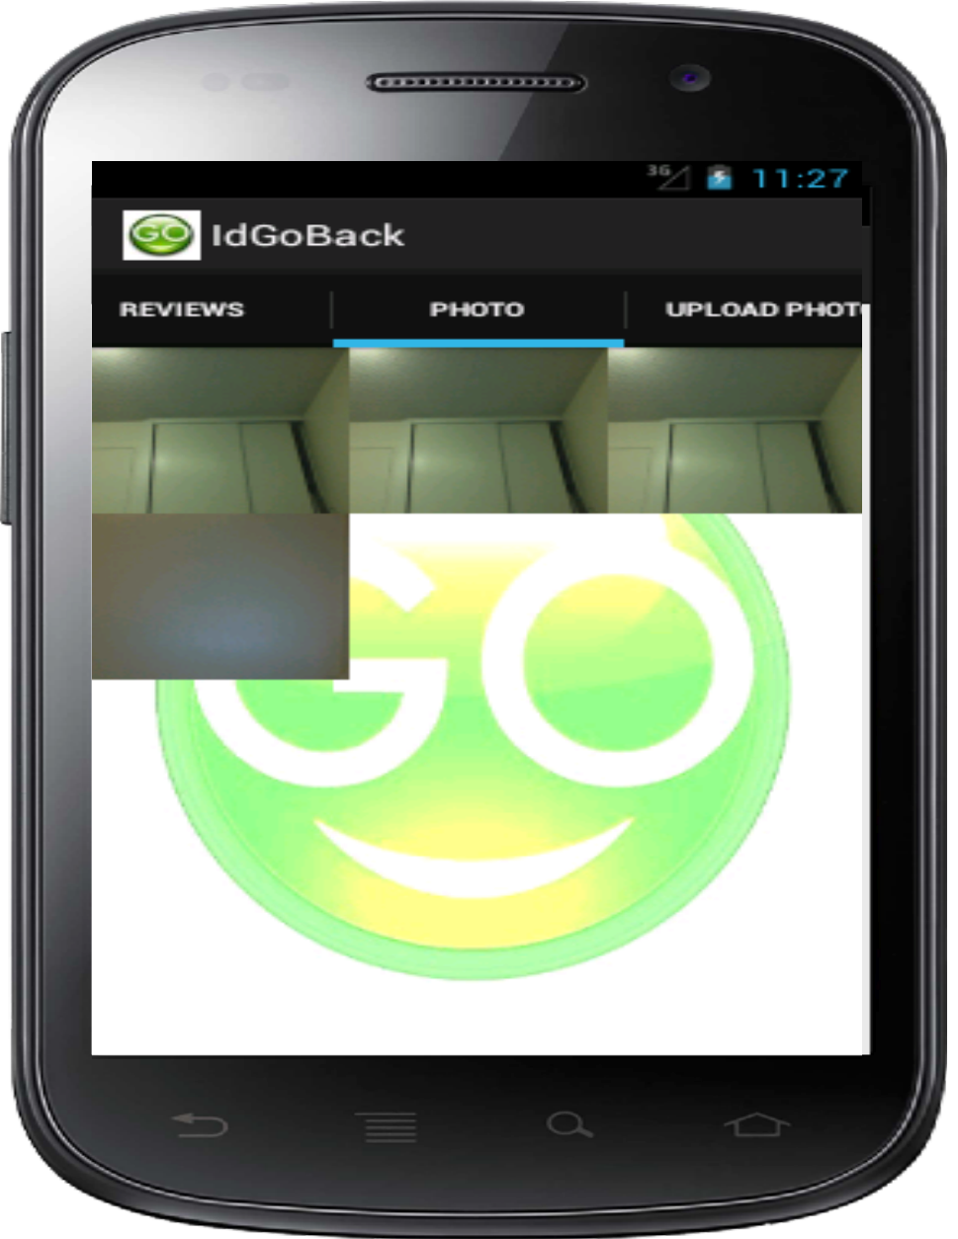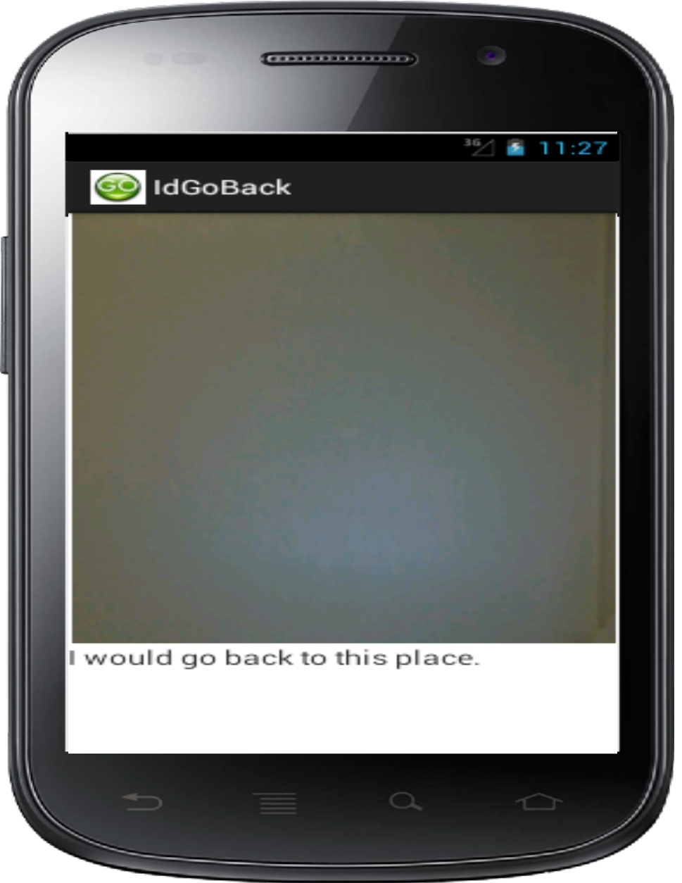

Figure 5: View photos shared by IdGoBack users

1. Upload Photo

When user clicks on Upload Photo tab, all the photos stored in the online library are loaded on the screen as displayed in the Figure 6.

User is able to upload photo for chosen place from uploading photos from online library or taking a new photo by clicking on the camera button on the bottom of the screen.

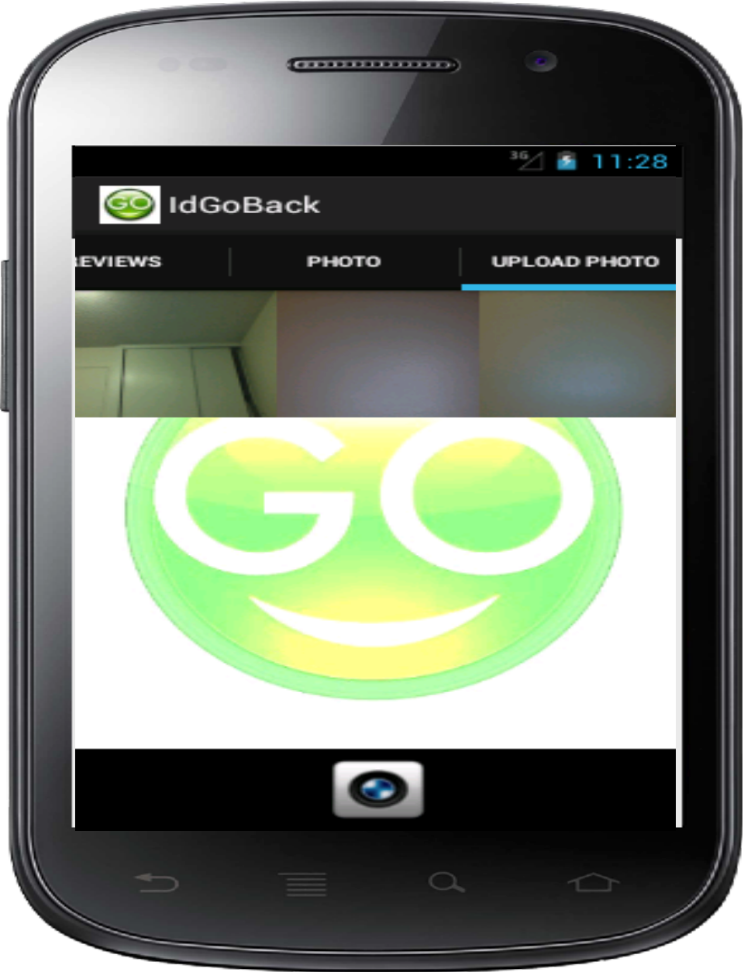

Figure 6: Online library pictures are loaded when Upload Tab is clicked

When user clicks on the photo on the screen, user is directed to another screen with a larger size photo, and user is able to add review for the photo as in Figure 7a, and then user can upload the photo by clicking on the upload button. The uploading picture is shown in the Photo tab immediately and stored in the database as well.

When user clicks on the camera button, after taking a new photo, there is a dialog popping out allowing user to add reviews as in Figure 7b. When user clicks on submit button on the dialog, the photo is also shown in Photo tab and stored in database.

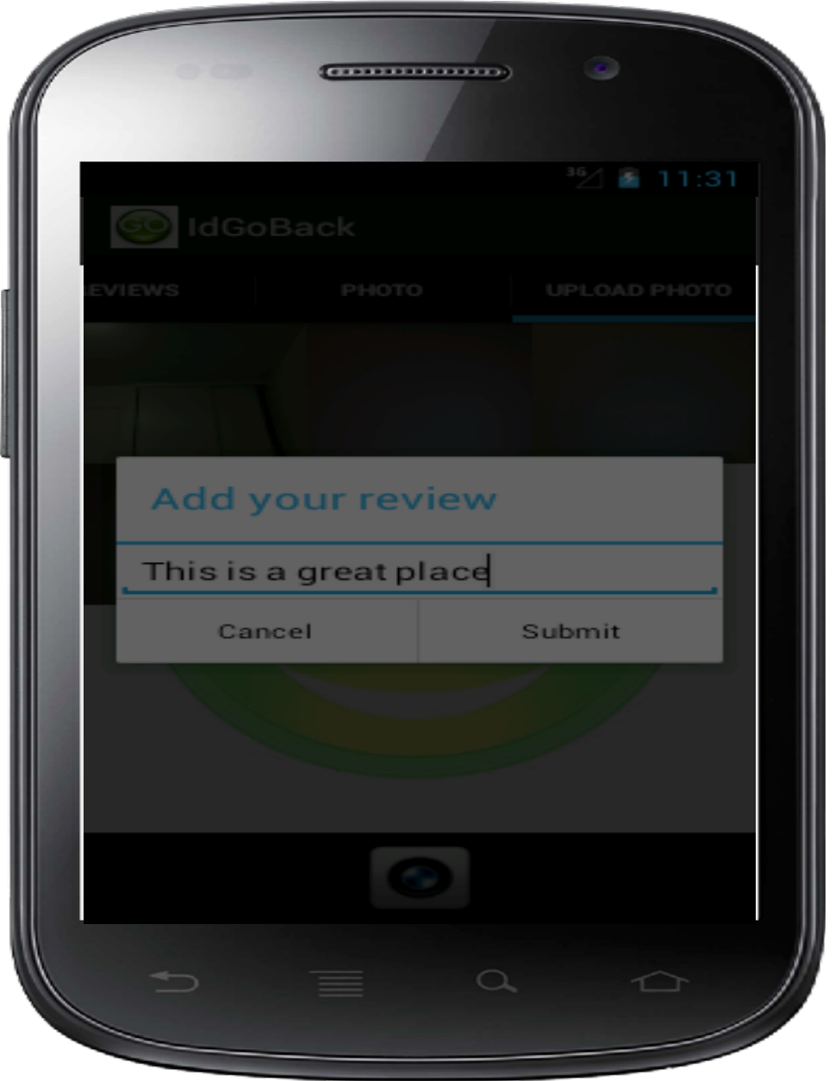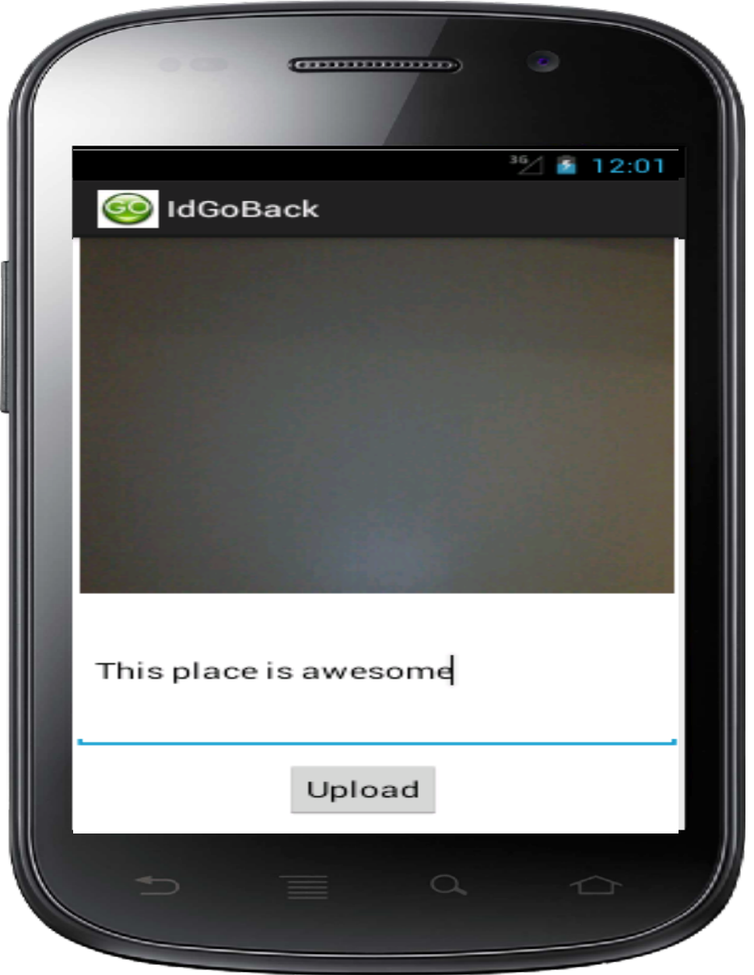

(a) (b)

Figure 7: Upload photo from online library (a) and from camera (b)

1. Photo Capture
2. Home

When user clicks on the Home tab, user sees their profile information including the user name, email address, their profile picture, and phone number (if available) as displayed in Figure 8a.

From Home tab, user is able to update their profile picture by clicking on the icon on the left. When user clicks on the profile icon, there is a dialog sliding up from the bottom providing user options to update their profile picture such as taking new picture from camera, choosing from album in internal memory, choosing from online library, or canceling updating profile picture as displayed in Figure 8b.

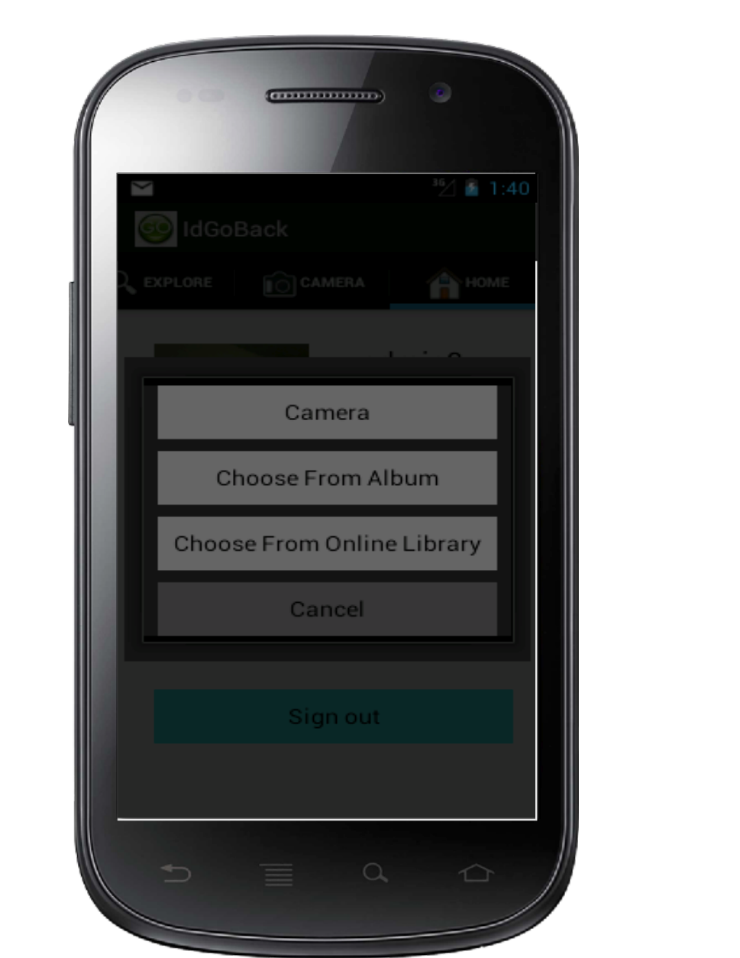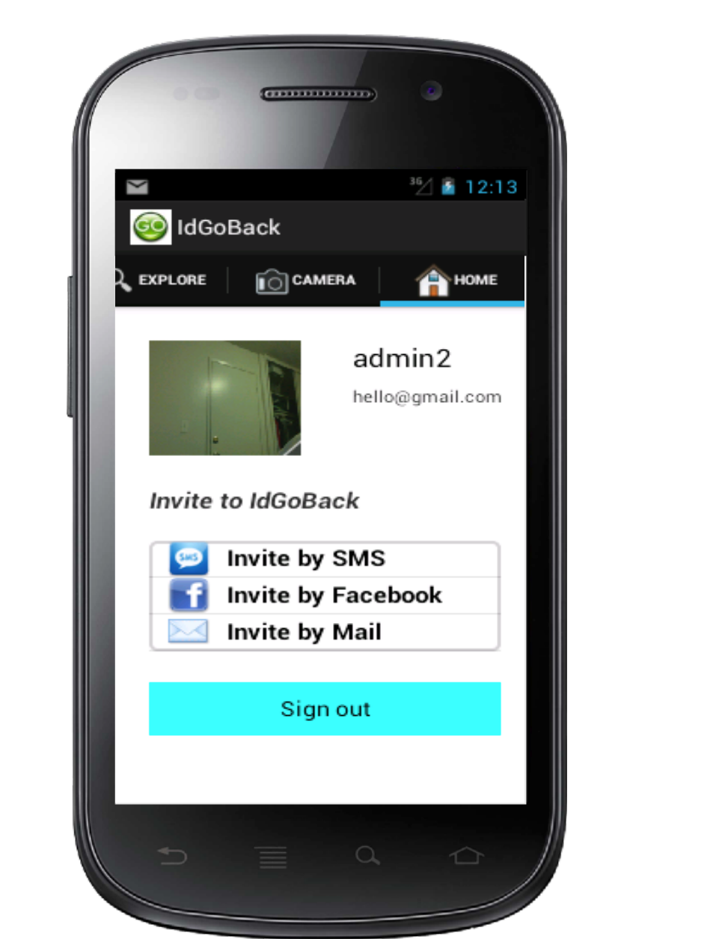

(a) (b)

Figure 8: Home UI (a) and Update Profile Picture (b)

Also, user is able to send invitation to their friends through SMS, Facebook (if they log in with Facebook), or email. When user clicks on Invite by SMS, user is directed to the built-in SMS dialog and user just needs to provide a phone number of whom user wants to invite to the application, and then send to that number. When user clicks on Invite by Mail, user is asked to enter the email of which user wants to send invitation to. When user clicks on submit button of dialog, user is directed to regular email dialog.

In case user log in with Facebook, the option Invite by Facebook shows in the screen. When user clicks on it, there is a Facebook dialog popping out as displayed in Figure 9 and user just needs to choose and send invitation to their Facebook’s friends.

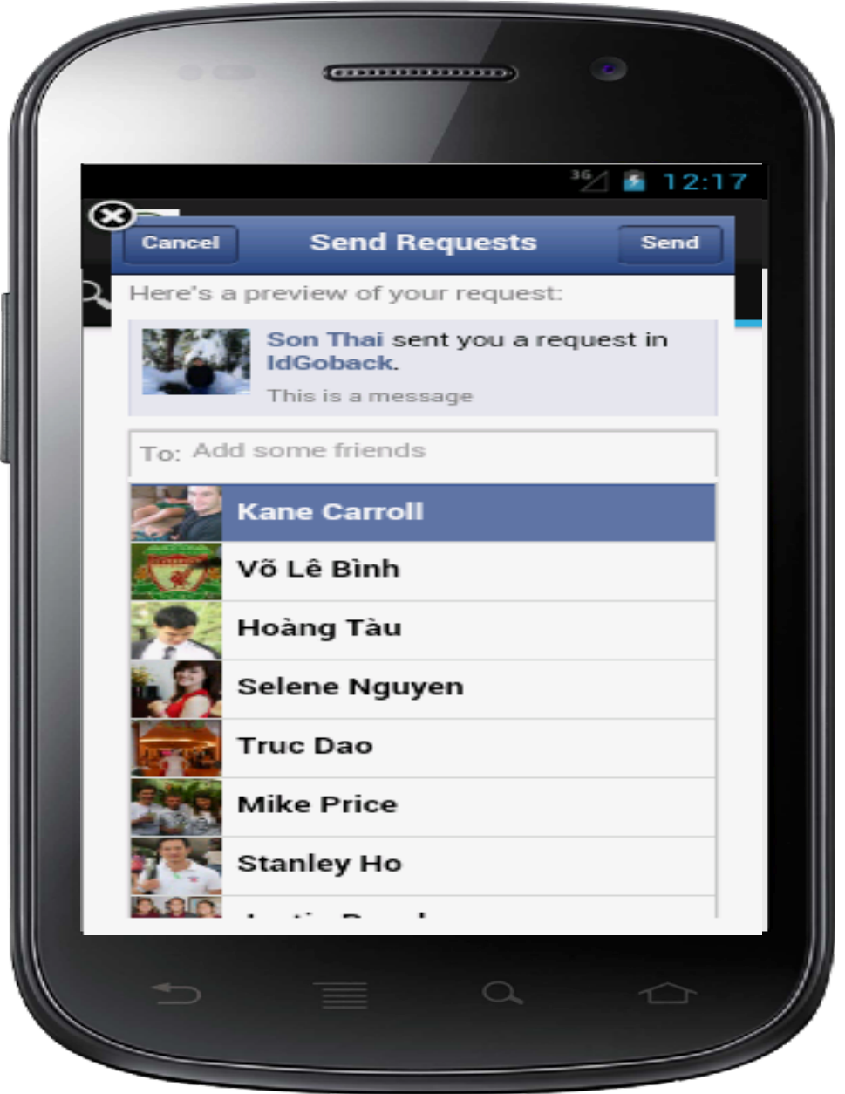

Figure 9:Invite Friend by Facebook

The Sign out button allow user to log out of IdGoBack application for both users log in with IdGoBack account or Facebook account.

## Non-Functional Requirements

## Evaluation Criteria

* Is Facebook logged in/ logged out successfully?
* Can users create a new IdGoBack account?
* Does application require users to enter their email when they register for a new account?
* Can users log in with a new account that they create?
* Can users reset the password if they forget?
* Does the item list pop up after users click on the Explore button?
* When users click on the item on the list, are they directed to information details of the item?
* Can users click on the website link in the Info tab and do to the website?
* Do users get the direction from their current place to the chosen place when they click on the Direction button?
* Are the reviews loaded when users click on Reviews Tab?
* Can users add reviews from Add review button and it immediately updates in the review list?
* Do users see the photo loaded in Photo Tab and Upload Photo Tab?
* Can they click on the photo to see larger size photo and its review?
* Can users take picture and add review for the picture after clicking on Photo Upload Tab?
* Is photo stored in the database when users upload it?
* Can users take picture from Camera tab and save it to database or share it on Facebook account (if they log in with Facebook)?
* Can users change the photo profile when they click on the photo icon?
* Does user’s name and email show on the home screen?
* Can user invite friends by SMS, email, or Facebook?

# Experiments

## User Tests

We will conduct user-based experiments/tests to evaluate the ease and efficiency of use with our mobile application. These experiments will ask users to complete fundamental operations of the IdGoBack mobile application. This may include writing a review or uploading a picture for a local business or restaurant, as well as signing up for the application or any other fundamental tasks.

## Expected Outcomes

Based on our experiments, we could log in and log out Facebook successfully. Also, we could take picture with the implementation of Camera and those pictures were stored and loaded correctly. Users could sign up with a new IdGoback account and log in with it. Besides, all information of business, places, restaurants, and etc. is fully loaded when users used explore function. Furthermore, users could invite friends to join the app through emails, Facebook, and users could share their pictures on their Facebook when they logged in application with their Facebook account.

# Conclusions

Nowadays there are many existing commercially mobile applications that help users to search best places, business, restaurants, and etc. However, users find it hard to used and complicated, and they are not satisfied with them because of missing features. Therefore, we have designed and implemented IdGoback application to provide users with a reliable and easy to use mobile application. Also, IdGoback connects users to allow for easy for easy photo and review sharing of the places they would "Go Back" to.